

The University of Azad Jammu and Kashmir, Muzaffarabad

Name Kamal Ali Akmal
Course Name | Software Designs and Architectures
Submitted to | Engr. Daniyal Nazir
Semester | 3rd
Session | 2024-2028
Roll No | 2024-SE-38
Lab No | 09
Submission date | 2 February 2026
Layered Architecture for a Library Management System

Objective
The objective of this lab task is to understand and apply the concept of Layered (Hierarchical) Architecture in software system design by designing a layered architecture for a Library Management System.

Introduction
Layered Architecture is a software design pattern in which a system is divided into multiple layers. Each layer has a specific responsibility and communicates only with the adjacent layer. This approach improves system organization, maintainability, scalability, and clarity.
In this lab task, a Library Management System is designed using three main layers:
- Presentation Layer
- Business Logic Layer
- Data Access Layer

System Overview
The Library Management System allows users to:
- Search for books
- Borrow books
- Return books
- Manage users
- Calculate and manage fines
To handle these operations efficiently, the system is divided into layers, where each layer performs a specific role.

Layers of the System
1. Presentation Layer
The Presentation Layer is the topmost layer of the system. It represents the user interface through which users interact with the Library Management System.
Responsibilities:
- Display information to users
- Take input from users
- Forward user requests to the Business Logic Layer
- Show responses received from the system
Components:
- Search Book UI
- Borrow Book UI
- Return Book UI
This layer does not contain any business rules or database logic.

2. Business Logic Layer
The Business Logic Layer is the core layer of the system. It contains all the business rules and decision-making logic.
Responsibilities:
- Process user requests
- Apply business rules
- Validate operations
- Communicate with the Data Access Layer
- Return processed results to the Presentation Layer
Components:
- Book Service
- User Service
- Fine Calculator
This layer ensures that system operations follow defined rules and policies.

3. Data Access Layer
The Data Access Layer is the lowest layer of the system. It is responsible for interacting with the database.
Responsibilities:
- Store data in the database
- Retrieve data from the database
- Update and delete records
- Handle all database-related operations
Components:
- Book DAO
- User DAO
- Loan DAO
This layer does not contain business logic or user interface code.

UML Package Diagram Description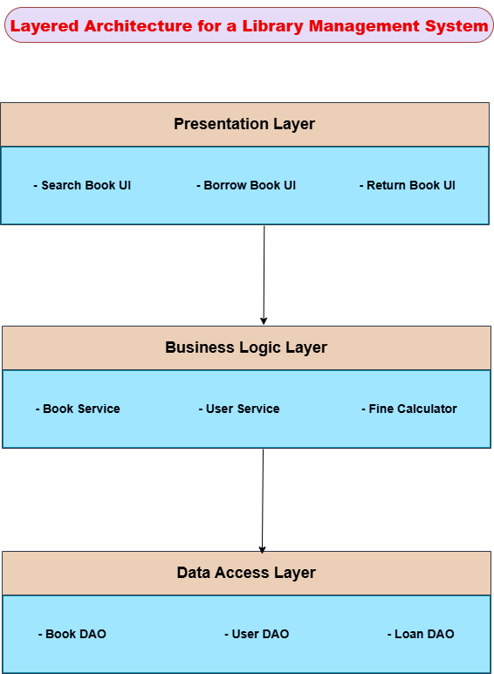
The UML package diagram illustrates the layered architecture of the Library Management System. The Presentation Layer is placed at the top, followed by the Business Logic Layer in the middle, and the Data Access Layer at the bottom. Arrows indicate the flow of requests and responses between layers, showing that communication occurs in a top-to-bottom manner.
Example Interaction: Borrowing a Book
The following steps explain how a request flows through the system when a user borrows a book:
- The user selects the Borrow Book option through the Presentation Layer.
- The Presentation Layer sends the request to the Business Logic Layer.
- The Business Logic Layer checks book availability and user eligibility.
- The Business Logic Layer requests book and user data from the Data Access Layer.
- The Data Access Layer retrieves and updates the required data in the database.
- The result is sent back to the Business Logic Layer.
- The Business Logic Layer confirms the transaction.
- The Presentation Layer displays a success message to the user.

Conclusion
Layered Architecture provides a structured way to design software systems by separating concerns into different layers. In this Library Management System, each layer performs a specific role, making the system easier to understand, maintain, and extend. This design improves code reusability and overall system efficiency.

